
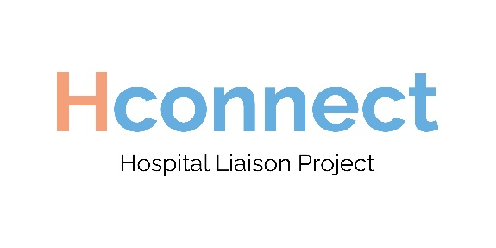
Acceleration Reform Fund - Carer Community Fund
The ARF Carer Community Fund have grants available for voluntary, community and social enterprises to pilot innovative projects that support Carers within their local communities. New and current Carers will be connected to groups, hubs and activities in their local community that improves wellbeing, enhances knowledge and learning and connects Carers to local support services.
For more information, including eligibility, key facts and grant amounts please read the fund guidelines.
Your organisation
Please describe details of your organisation including who you support and the activities.

Contact details
First name –
Last name –
Job title –
Email –
Telephone number –
Organisation details
Organisation name –
Street –
Town/City -
County –
Postcode –
Email –
Telephone number –

Your project
Your project name -
Please describe the project you are applying for funds for?

Is your project available for all Carers or specific Carer groups?

How many Carers do you believe will benefit from this project?

Which geographical area will your project cover?

How much are you applying for?

Please provide a project cost breakdown:

Please confirm you have the following documents available upon request:
☐ The organisations/groups constitution/governing bodies
☐ Copies of recent bank statement
☐ Last full year’s accounts
☐ Safeguarding Policy (Child Protection and /or Vulnerable Adults)
☐ Equal Opportunities Policy
☐ The names and addresses of your Trustees or management committee
☐ Public Liability Insurance document covering the duration of the project
☐ GDPR Policy/Privacy Policy

Declaration
We are authorised to submit this application on behalf of the group and certify that the information enclosed is correct. By submitting this application form, we agree to abide by the terms and conditions stated below.

Terms, Conditions & Reporting Requirements for the ARF Carers Community Fund
We understand and agree that:
- The grant will be used for the exact purpose specified in the approved application and as summarised above, and no other purpose.
- No significant changes can be made to the project without the written approval of the Grants Panel.
- No purchase or order of any goods or services specified by this approved application will be made before successfully completing grant due diligence.
- We will acknowledge Acceleration Reform Fund and H-Connect in any publicity material we produce about the project.
- We will spend the grant award within one year of the date of the offer letter
- Enhanced DBS checks will be completed for all relevant roles.
- Public Liability Insurance must be active throughout the project period.
- If we do not spend the entire grant, we will promptly return any unspent balance to Derbyshire Carers Association.
- We will monitor the project, and complete and return all required monitoring reports to the schedules provided.
- We understand that Derbyshire Carers Association will not increase the amount of the grant if we overspend.
- We will keep all financial records and accounts, including receipts for items bought with the grant, for at least two years from receipt of the grant.
- Derbyshire Carers Association may withhold the grant, or ask us to repay the grant, in whole or part, in the following circumstances;
  - If we fail to keep this contract in any way
  - If the application form was completed dishonestly or the supporting documentation gave false or misleading information
  - If we do not implement and follow our Safeguarding Policy (if appropriate) in all aspects of our activities
  - If any member of our governing body, staff or volunteers acts dishonestly or negligently in their work on behalf of the group at any time during the project
  - If we close down, become insolvent, go into administration, receivership or liquidation (sequestration), or make arrangement with our creditors.
- These terms and conditions will apply until we have spent the entire grant and Derbyshire Carers Association has received and approved our Monitoring Report.

Please tick this box to confirm that you agree to abide by these terms and conditions.
I agree ☐
Date
Signature
Please return completed application forms to helen.weston@derbyshirecarers.co.uk before 5:00pm on Friday 18th April 2025

